MGMS – Create Notification

Functional Specification Document

Ver. 1.4

Version History
Date | Description
25-Nov-2010 | First Draft

Table of Contents

Version History 2
1 Introduction 4
1.1 Purpose 4
1.2 Scope 4
1.3 Assumptions 4
1.4 Constraints 4
2 New Notification 4
3 Business Rules 6
4 Status Messages 6

Introduction

Purpose

This document provides the requirements and functional specifications for the Notification Creation section of the Multisite Grant Management System project.
This is not a project plan or a design document. It is a guide for system architecture and development, not for phasing, timelines or deliverables.
Finally, this is a ‘living document’ and the specification will change, continuously, as the project proceeds. More details will be added and the existing information edited as the requirements, scenarios and use cases evolve in the course of the project.

Scope

Assumptions

Constraints

New Notification

Screen & Control Description

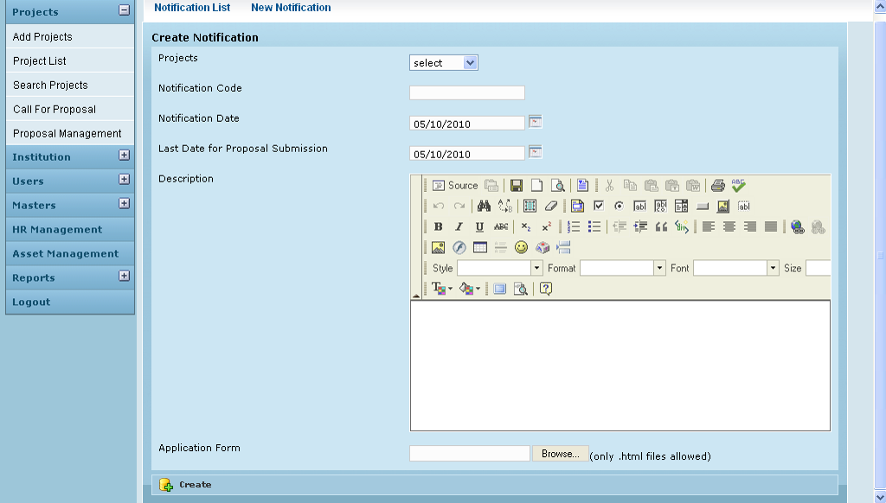

Field /Label | Input-Control | Data Type | Remarks
Notification List | Link
New Notification | Link
Create Notification
Projects | Listbox | String | projects>code
Notification Code | Textbox | String | notification>notification_code
Notification Date | Calendar | datetime | notification>notification_date
Last Date for Proposal Submission | Calendar | datetime | notification> proposal_submission_last_date
Description | Notepad
Application form | Textbox – auto populated |  | where? Any other details?  For uploading the application form
 | “Browse” - button
 | (only .html files allowed) - label
Create | Button

Upload Attachments

Screen & Control Description

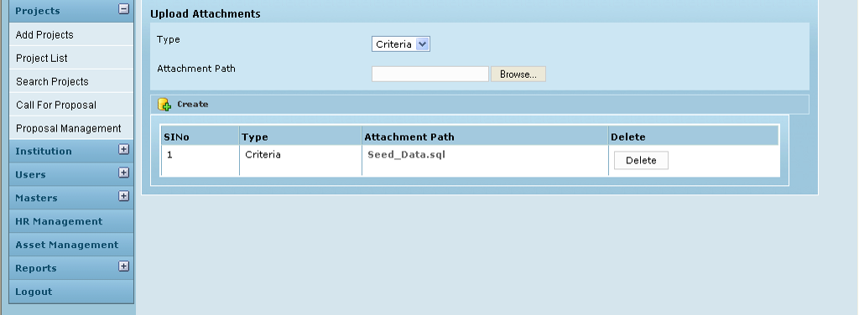

Field /Label | Input-Control | Data Type | Remarks
Upload Attachments
Type | Listbox
Attachment Path | “Browse” button
 | Textbox – auto populated
Create | Button
SlNo | Auto populated
Type | Auto populated
Attachment Path | Auto populated
Delete | “Delete” - button

Business Rules

Status Messages

Sl No | Status Message
1 | Created Successfully
2 | Updated Successfully
3 | Deleted Successfully
4 | The Requested Record Not Found
5 | The Record can't be deleted, Already in use
6 | The Record Already Exists
7
8

